**AR Spark**

Guided Onboarding & Creative Companion for FLAM AR

Submitted by

Mamillapalli Jaya Krishna Chandra-AP22110010938

**Bachelor of Technology**

In

**Computer Science and Engineering**

**School of Engineering and Sciences**



**SRM University-AP**

**Neerukonda, Mangalagiri, Guntur.**

**Andhra Pradesh – 522 240**

**April,2025**

**Executive Summary**

FLAM’s AI-powered publishing platform enables brands to craft immersive AR campaigns, yet first-time users often abandon AR apps due to confusion and lack of inspiration. AR Spark embeds an interactive onboarding walkthrough and ongoing creative companion directly in the FLAM AR mobile experience. It quickly teaches novices core AR interactions, then drives daily engagement through personalized challenges and contextual tips. The result: higher retention, faster time-to-value for marketers, and richer user-generated content on the platform.

**1 Problem Statement**

•High first-session drop-off: ~70 % of AR/VR app users churn within a week, largely because setup and controls feel opaque.

•Steep learning curve: New users rarely understand scanning, placement, or editing without guidance; marketers lack 3D skills.

•Under-utilized creativity: Even engaged users struggle to imagine fresh AR use-cases, limiting repeat sessions and content diversity.

•Brand risk: Confusing AR experiences reflect poorly on client campaigns and jeopardies ROI.

Opportunity: A seamless, in-app mentor that shows—not just tells—users what to do, sparking confidence and ongoing discovery.

**2 Product Vision**

Empower anyone marketer or consumer to create, explore, and share compelling AR stories within minutes of installing FLAM AR. AR Spark acts as a friendly guide: teaching by doing, inspiring new ideas daily, and personalizing tips so every session feels fresh and rewarding.

**3 User Personas & Insights**

| Persona | Goals | Pain Points |
| --- | --- | --- |
| Priya \– Marketing Manager | Launch engaging product campaigns fast | No AR expertise; unsure where to start; needs ROI proof |
| Alex \– Casual Consumer | Have fun & share cool content | Never used AR; confused by controls; gets bored quickly. |

Both personas need clarity, immediate value, and continuous inspiration to stay engaged.

**4 Proposed Solution: AR Spark**

**4.1 Feature Overview**

1. Interactive Onboarding (≈90 s)

• Camera permission & plane detection coaching

• Guided placement of a mascot + simple object editing

• “Wow-moment” animation and quick next-steps prompt

2. Ongoing Creative Companion

• Daily/weekly AR challenges with templates

• AI-driven personalised suggestions

• On-demand contextual help (chat or tap-for-tip)

3. Gamified Engagement Loop

• Complete → share → reward/streak → new challenge

**4.2 Key UX Principles**

• Learn-by-doing: Minimal text, actions embedded in scene

• Delight early: Deliver a magical visual payoff inside first minute

• Progressive disclosure: Reveal tools contextually, avoid overwhelm

• Personalization: Use FLAME’s AI to tailor challenges & tips

• Respect control: Skippable, non-intrusive, user can opt out of hints

**4.3 Visual Flow Diagram**

Figure 1: Onboarding (top lane) leads into a recurring engagement loop (bottom lane).

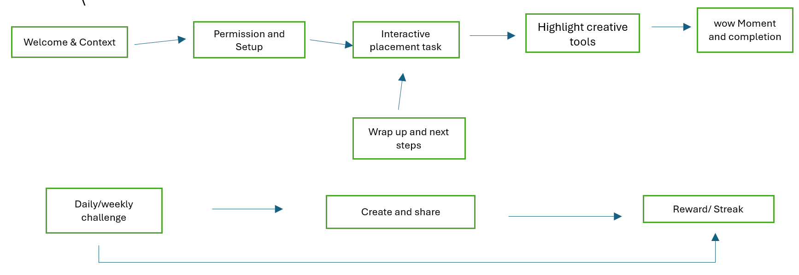

**5 Product Thinking & Rationale**

1.Improved First-Time UX – Hands-on tutorial removes uncertainty, raising onboarding completion to >90 %.

2.Engagement Flywheel – Challenges and streaks create a habit loop, aiming to lift Day-7 retention from ~15 % to >25 %.

3.Creative Enablement – Templates and AI tips lower barrier for marketers, shortening time-to-first campaign.

4.Competitive Edge – Few AR platforms embed a persistent AI mentor; this differentiates FLAM in B2B pitches.

**6 Success Metrics**

| **Metric** | **Baseline** | **6-mo Target** |
| --- | --- | --- |
| **Onboarding completion** | — | >90 % |
| **Day-1 retention** | ~30 % | 45–50 % |
| **Day-7 retention** | 15 % | ≥25 % |
| **Users creating ≥1 AR scene wk-1** | 12 % | 25 % |
| **Avg. AR campaign dwell-time** | – | +20 % |

**7 Implementation Snapshot**

| **Layer** | **Key Elements** |
| --- | --- |
| **Frontend** | ARKit/ARCore + custom overlays; mascot/asset bundle |
| **Backend** | Challenge CMS; analytics; recommendation engine |
| **AI** | NLP help-bot; behavioural recommendations |
| **Rollout** | Phase 1 onboarding → Phase 2 challenges → A/B test |

Risks: performance overhead, notification fatigue, content freshness.

Mitigations: lightweight assets, user-tunable reminders, content ops calendar.

**8 Roadmap & Next Steps**

1.Design Sprint (2 wks): finalise tutorial script, asset list, success metrics.

2.MVP Build (6 wks): onboarding + basic analytics.

3.Pilot A/B Test (3 wks): measure uplift vs control cohort.

4.Challenge Engine (4 wks): CMS & weekly content pipeline.

5.AI Help-Bot Beta (4 wks): FAQ coverage → expand via user logs.

**9 Conclusion**

AR Spark ignites the user journey. By pairing an engaging first-minute tutorial with a sustained creative companion, FLAM can convert curious first-time installers into loyal creators and give marketing clients measurable campaign lift. Let’s light the spark and keep it burning.